Acceptance test:
Help button statistics.
Test criteria
A help screen explaining the gui shows after clicking the button
User opens the program and sees the main screen
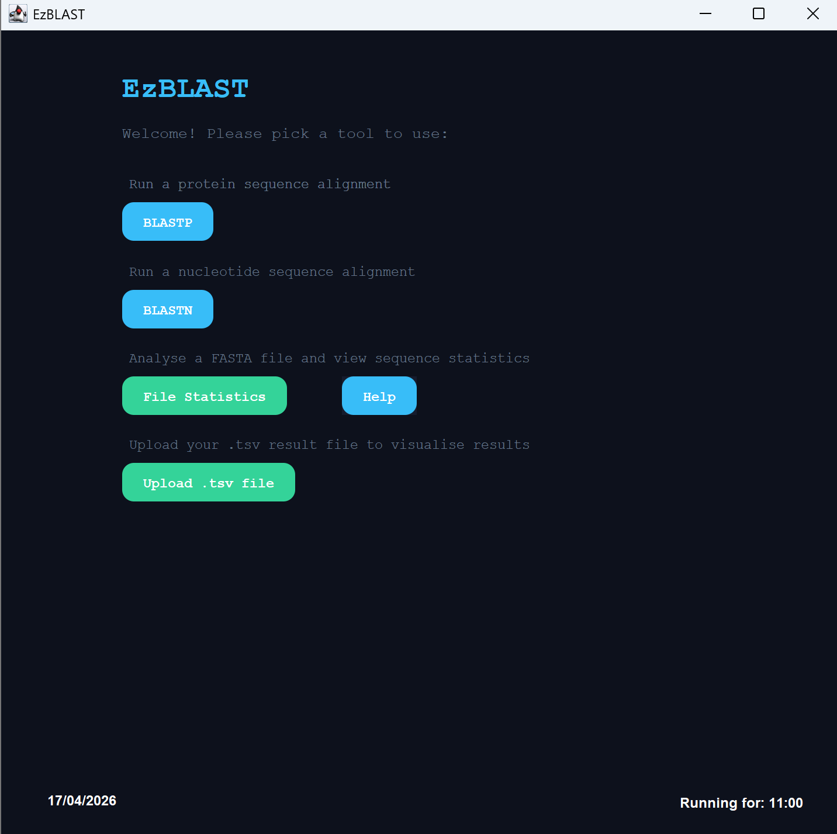
The user selects their file to find statistics about
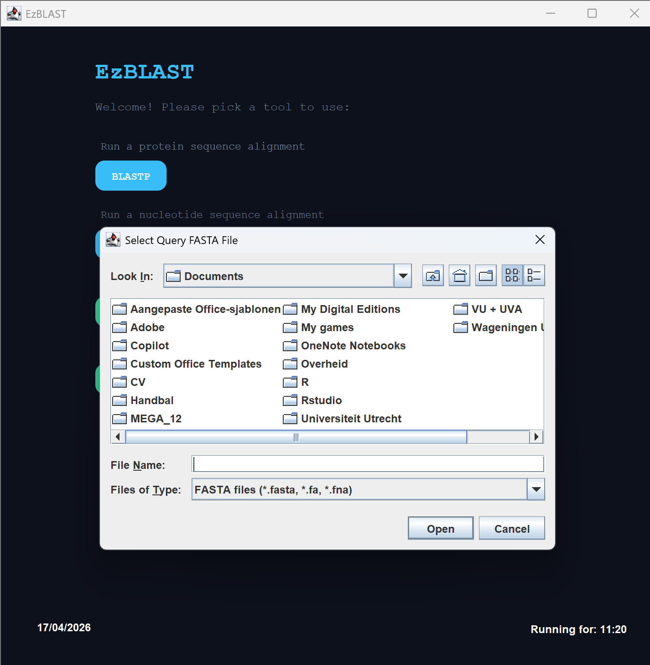
The user is confused about the page and requires help.
